TABLE OF CONTENTS
Introduction
Purpose of this Document
Scope of the Development Project
Functionality
HMS Functionality
General Description
Application Description
External Interface
Technology used
Hardware and Software Requirements
Hardware Requirements
Software Requirements
Other Functionalities
Security
Performance requirements
safety

1. Introduction:

To Provide an integrated Solution for the Hospital, which
• Helps in Efficient Management of the Hospital.
• Enhance Patient Care.
• Improve work efficiency.
• Enable the Growth of the Hospital.

1.1 Purpose of this Document:

The purpose of this SRS document is to provide a detailed overview of our software product “Hospital Management System”, its parameters and goals. This document describes the project's target audience and its user interface, hardware and software requirements. It defines how our client, team and audience see the product and its functionality.

1.2 Scope of the product:

It authenticates the user by matching the User ID and the access code (which in turn may be
Generated using some cryptographic algorithm) against the values stored in the database. It enables in creating new Users in the system i.e. it provides a registration form which makes the user to enter the new user’s details. It provides separate billing method for indoor and outdoor patients, corporate and individual patients.

1.3 Functionality: There are 15 major modules.

The various modules are:

➢ Reception Management
➢ Patient Registration
➢ Inpatient Management
➢ Out Patient Management
➢ channeling services
➢ Payments
➢ Maintenance
➢ Store
➢ Pharmacy
➢ Radiology
➢ Dental
➢ Financial Accounting
➢ Payroll
➢ Reports
➢ User Accounts

1.3.1 HMS Functionality:

➢ Reception Management:

Reception is the first point of interaction for anybody coming to the Hospital. It has all the information of the patients, doctors, departments and activities of the Hospital. All enquiries and appointments are scheduled through this module.

❖ Patient Related Enquires:
• Bed Allotment
• Admission Details
• Payment Details
• Discharge Details
❖ Doctor Related Enquires:
• Availability Details
• Appointment Schedules
• Operation Schedules

➢ Patient Registration:

Every patient who visits the hospital has to get registered prior to getting any consultation, treatment or investigations done. Registration of patients involves accepting certain general and demographic information about the patient. The patient is allocated a unique Registration number and a Patient Identification number. The Patient ID will remain same for his all subsequent visits to the hospital whereas he will be allocated a new registration number on every visit. The consultation charges (if applicable) can also be collected for the OPD patients during registration and a receipt will be generated.

The following information is required for the registration of OPD Patient:

❖ Patient details like Name, Age, Sex, Address, Contact number, etc.
❖ Department and Consultant to be visited.

For Inpatient the additional information requirements are:

❖ Room / Bed requirements
❖ Consultant In charge
❖ Treatment required

After registration an OPD Card is printed for the OPD patients, which list all his registration information. This card is used for the prescription writing by the consultant.
An Admission form is printed with all the registration details for Indoor patients, which serves as the cover page of the patient file.

➢ Inpatient Management:

The Inpatient module is designed to take care of all the activities and functions pertaining to Inpatient Management. This module automates the day-to-day administrative actives and provides instant access to other modules, which leads to a better patient care. It provides comprehensive data pertaining to Admission of Patients & Ward Management: Availability of beds, Estimation, Collection of advance, planned admission, Emergency admission and so on.

It provides some queries like:

❖ Inpatient Admission
❖ Consultant Visit Entries
❖ Bed Transfer Details
❖ Daily Drug Requisition
❖ Daily Progress
❖ Advance Collections
❖ Patient Operation Details
❖ Discharge Intimation
❖ Discharge Notification Summary
❖ Patient Attainder Details

➢ Out Patient Management:

After the registration the patient comes to the consultation chamber, where the consultant records his history, diagnose and prescribe medicines & investigation.

The Consultant notes down the following details on Patients:

i. Complaints
ii. History
iii. Diagnosis
iv. Investigation
v. Medicines
vi. Advice
Vii. Next Visit

This information is then entered into the patient data by the consultant or the operator at the Counter. It serves the purpose of tracing patient’s visits history and also as a Feedback for research & analysis. The prescription can also be scanned and saved. The Scanned data can be entered later into various fields by the operator.

➢ Channeling Services:
This module maintains the appointment details of the Inpatients and Outpatients.

➢ Payments:
❖ Inpatients:
Indoor billing module has a supervisory role. The entries for billing are automatically transferred to the patient bill by the respective departments, which provide the service. The services are charged as per the category/panel/package applicable.
Here the bill is compiled and the payment collected from time to time. Provisional and Final bills are generated which provides complete information about the Services availed, its Charges, Advance collected, appropriate Receipts, Refunds, Credit notes, Concession allowed, etc.

Salient Features:

1. Collection of Payment by Cash/Credit Card/ DD or Cheque.
2. Receipts, refunds, Credit Note Generation.
3. Provisional & Final Bills.
4. Department wise services availed.
5. Scrutinizing the Deposit Exhaust list and sending requisition for deposit.
6. Automatic scrutiny of the credit limit available to the patient
7. Provision to bill a patient against another account (LIC account/company account/Donors account etc.)
8. Additional payment for Ambulance/attendants at discharge if required.

❖ Outpatients:

For billing of any OPD service like Pathology Tests, or any imaging investigation, the patient moves to OPD billing counter. Here the services are charged as per the rates already defined for various categories/ penal/ time etc to the patient with his Patient ID. The Payment is collected for the service provided and a receipt is generated. This module works as an interface with the diagnostic modules. All services will be automatically entered into the respective modules wherever required like lab & Imaging reporting.

The Salient features of this module are:

1. Record Charges to be taken from the patient.
2. Record details of the concession & concession authority.
3. Consultant charges are automatically picked according to general or emergency charges.
4. The charges for the services are automatically picked according to the category or panel of the patient.
5. The charges are also dependent on time when the service is being given to patient.
6. When patient revisits his information will be automatically picked using his identification number.
7. Patient can be defined under Cash & Credit OPD.
8. All relevant information is transferred to the Investigation departments.

➢ Maintenance:

This module helps the user to keep the equipment in operational condition or repair it to its operational mode.

❖ Hospital Service Maintenance
❖ Wards Maintenance
❖ Rooms Maintenance
❖ Doctor Maintenance
❖ Department Maintenance
❖ Medicines Maintenance

➢ Central Store:

This module deals with the inventory of all Hospital Equipments, Materials, Consumables, and Medicines, Implants & Asset items in different departments of the hospital along with their purchase and supplier details. Requisitions for different items/equipment are sent to this store from different departments and accordingly the Central Store issues items/equipment to various departments and generate purchase orders for purchases. This also maintains records of purchases, stock, and supplier list, item/equipment/material master tables. The Store module ensures that there is a round the clock availability of a sufficient quantity of drugs and consumable material for the patients in a mode that neither hinders efficient clinical work, nor it becomes a threat to the survival of the Store.

The Salient Features of this Module are:

1. Maintains the details of all items, its suppliers and purchase details.
2. Items can be categorized under different groups.
3. Items can be defined for the store i.e. a particular will be able to view only those items which comes under it.
4. Generate Purchase order linked with patient indents.
5. Maintain Separate Stock of Central Store & Multiple Sub Stores.
6. A particular store can indent items from all other stores.
7. Maintain vendor details from whom Items are being purchased.
8. Central Store can acknowledge return of purchased item.
9. Various area stores can return items that are not required by them back to the Central Store.
10. Strict Check on the Expiry Date of Medicines & Consumables.
11. Items can be issued according to FIFO & LIFO check
12. Maintain Reorder Level of Items and warn accordingly.

➢ Pharmacy:

The Pharmacy Module deal with the Retail Sale of medicines to OPD patients and Issue of medicines to the In-patients in the hospital. Its function includes, online drug prescription, inventory management and billing of drugs, consumables and sutures. This module is closely linked to the Billing Module and In-patient Module. All the drugs required by the patient can be indented from the various sub stores.

Salient Features:

1. This module enables complete control on pharmacy including Purchase & Issue of medicine to IPD or OPD Patient.
2. Medicines can be classified under different categories as per the salt or appearance.
3. Total amount of the bill for IPD Patient will automatically get added in his bill.
4. The Pharmacy can acknowledge the return of items and issue Credit notes.
5. Items cannot be issued after the expiry date.
6. Items can be issued according to FIFO & LIFO check.
7. Details of all vendors are kept in accordance with their transactions.
8. Maintain Reorder Level of Items.

➢ Financial Accounting:

A Financial accounting module is linked with hospital billing module. You get online accounting of all revenue generated along with expenses incurred. There is no need to enter the revenue entries as they are already fetched from the billing module. All relevant information for the staff salary/wages, consultant share, etc is available.

Salient Features of this module are:

1. All revenue entries are transferred automatically from billing module.
2. User defined ledger Groups & Accounts.
3. User definition of Cost Centre.
4. Department wise income detail.
5. Cheque Printing.
6. Graph with Key Reports.

➢ Payroll:

Keep track of all staff member’s attendance; there leave record and deductions.
Generate salary slip and other related reports.

Salient Features of this Module are:

1. Maintains complete record of all employees including the Employee Code, name, Demographic data, Salary in different heads, Department, Designation, PF account, ESI Account, etc.
2. Definition of Salary head as per formula or straight away.
3. Leave’s as per defined by user.
4. Salary settings as per monthly basis, or on wages basis.
5. Daily/ Monthly attendance record.
6. Short Term & Long Term Loans.
7. Record of employee’s in time, out time, lunch hours, over time.
8. Application of salary increment formula.

➢ Reports:

In this module the user can view the total data saved in the data base like ,
❖ Patients reports
❖ Doctor reports
❖ Hospital reports
❖ Payment reports
❖ Revenue reports
❖ financial reports
❖ Payroll reports

➢ User Accounts:

These module helps users to create there new ID and password and modifications to
there accounts.

2. General description:

2.1 Application description:
General
Registration
Appointment
Registration
Services
Lab Test
General Stores
Service Billing
Pharmacy
Radiology
Outpatient
Inpatient
Laboratory
Financial
Accounting
Administrator

❖ HMS integrate with:

• Database
• Applications

3. External interfaces:

Input from the user will be via keyboard input and mouse point and click. The user will navigate through the software by clicking on icons and links. The icons will give appropriate responses to the given input

3.1 Technology Used:

Visual Studio2010 and SQL server2008

3.2 Hardware and Software Requirements:

3.2.1 Hardware requirements:
❖ These are the minimum hardware requirements.

Hard disk: 80 GB.
Ram: 512 MB.
Processor: Intel Pentium4 or above.

3.2.2 Software requirements:
❖ These are the minimum software requirements.

Technologies: C# .Net 2.0
Database: SQL server(standard edition).
Operating system: Windows XP or above.

4. Other functionalities:
4.1 Security:

Each member is required to enter an individual Username & password when accessing the software. Administrators have the option of increasing the level of password security their members must use. The data in the database is secured through multiple layers of protection. One of those security layers involves member passwords. For maximum security of your software, each member must protect their password.

4.2 Performance requirements:

The performance of our software is at its best when the following are regularly done:
❖ Password Management
❖ Regular Database Archiving
❖ Virus Protection

4.3 Safety:

Humans are error-prone, but the negative effects of common errors should be limited.
E.g., users should realize that a given command will delete data, and be asked to confirm their intent or have the option to undo.

UML DIAGRAMS:
Class Diagram:

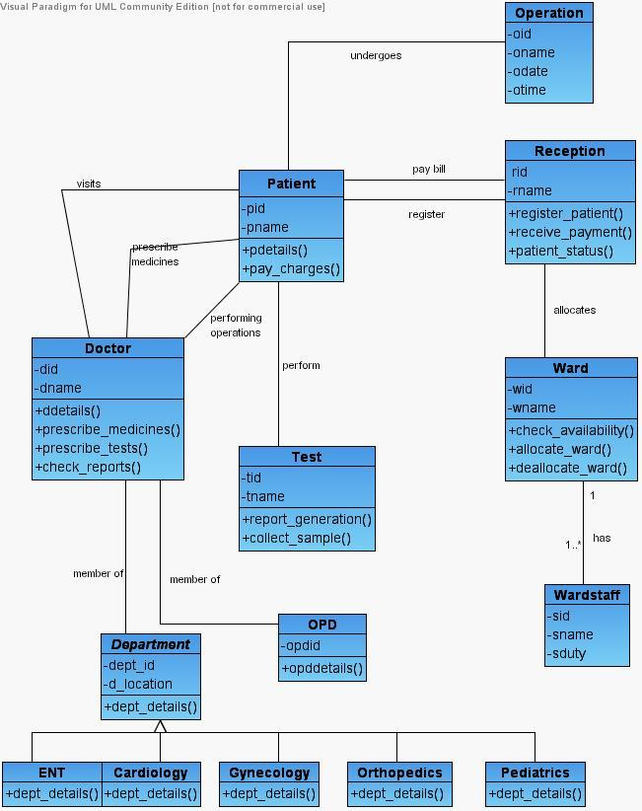

Collaboration Diagram:
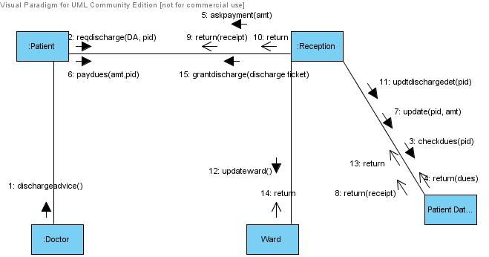

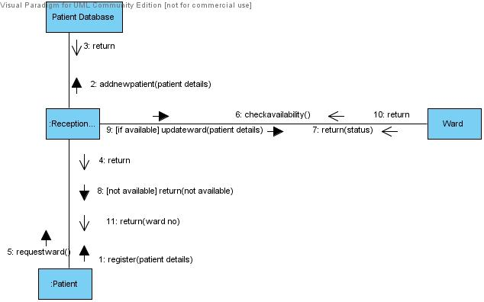
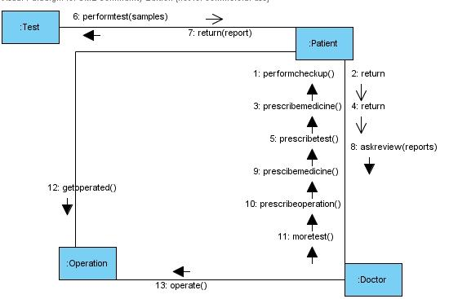
Activity Diagram:
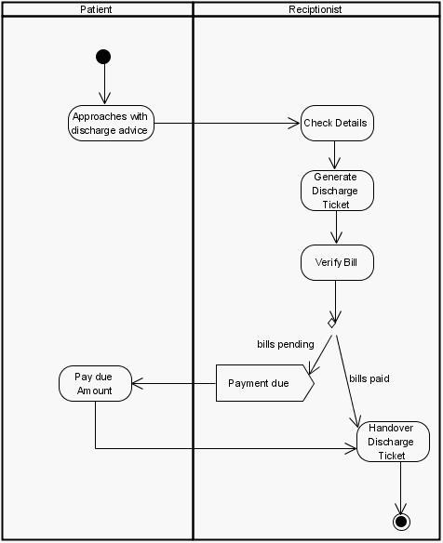

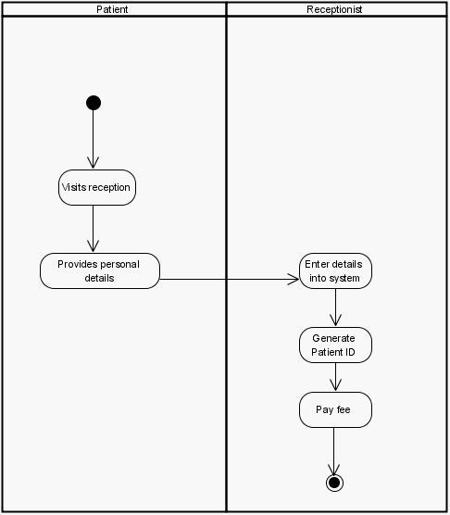
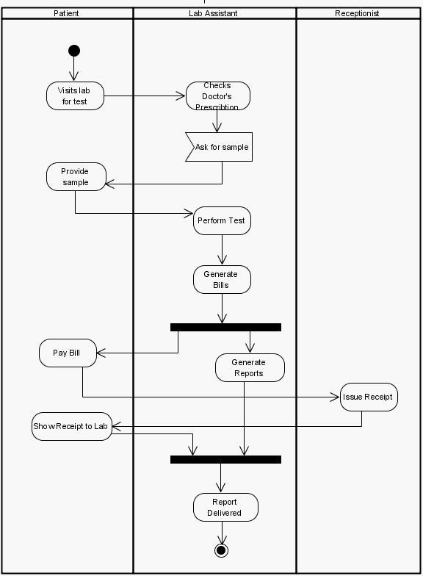

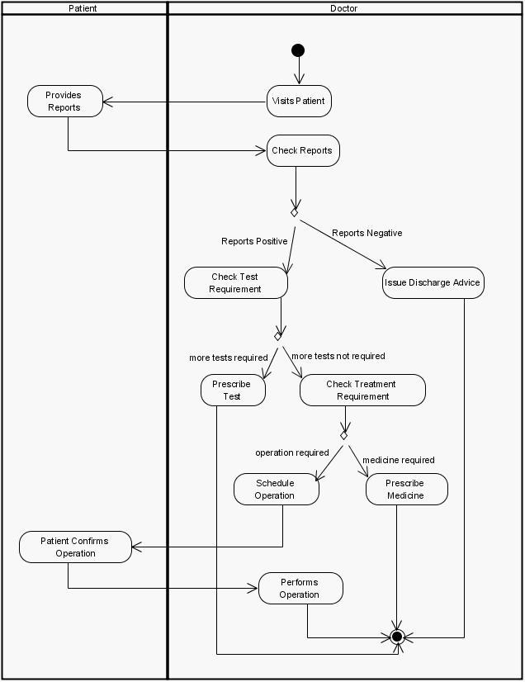
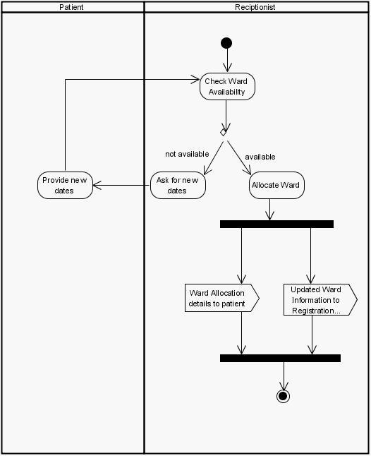

Sequence Diagram:

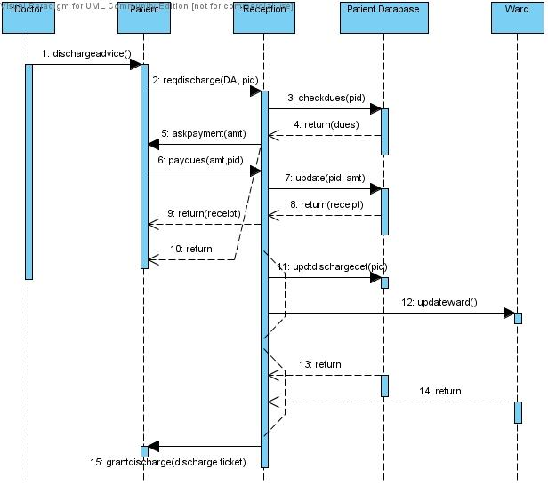

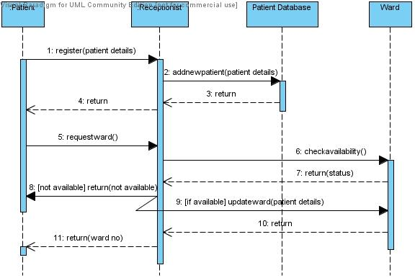

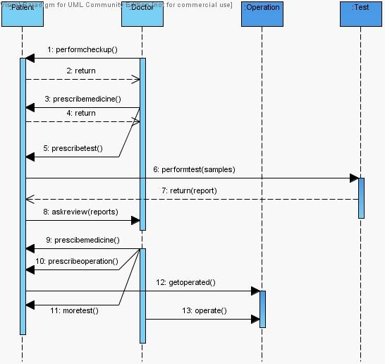

State Chart Diagram:
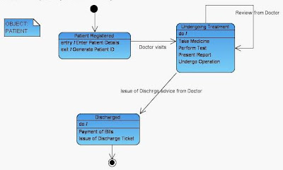

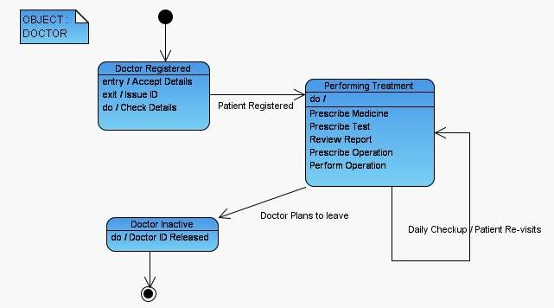

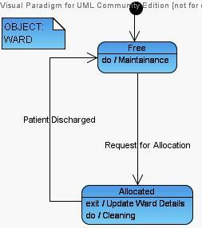

Use Case Diagram:
